Max Shi  
E 234  
Professor De Rosa  
November 30, 2020  
I pledge my honor that I have abided by the Stevens Honor System.  
Partner: Ashley McDermott

Homework 9

1. $$\dot{E}=\dot{m}\left(h+KE+PE\right) \\ \dot{m}=ρ*\dot{V} \\ \dot{m}=1000\frac{kg}{m^{3}}*175\frac{m^{3}}{s}=175000\frac{kg}{s} \\ h=0, KE=0 \\ \dot{E}=175000\left(gΔz\right)=175000\left(9.81\right)\left(80\right)=13734000 W=137.34 MW$$ Looking at the Hoover Dam, one of its generators produces around 130 MW, however, the Hoover Dam is triple the height and flows at 11000 m^3/s, so this would lead me to think this answer is not very realistic.
2. $$\dot{E}=\dot{m}*KE=\dot{m}*\frac{{7.5}^{2}}{2}=28.125\frac{kJ}{kg} \\ \dot{m}=ρVA \\ ρ=1.25\frac{kg}{m^{3}} \\ \dot{m}=1.25*7.5*\left(π*{0.25}^{2}\right)=1.84\frac{kg}{s} \\ \dot{E}=1.84*28.125=51.77 kW$$ Not realistic, a typical 50 cm fan does not need a power draw of 51.77 kW.
3. The velocity is maximized under isentropic conditions.  
   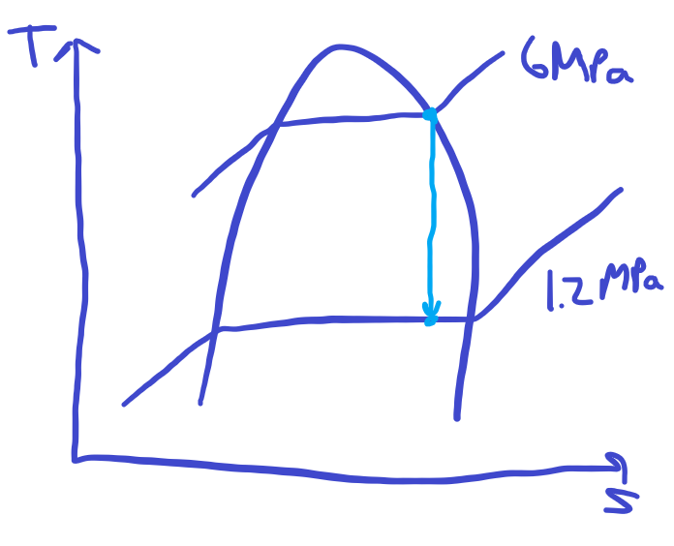 $${\dot{E}}_{in}-{\dot{E}}_{out}=0 \\ {\dot{E}}_{in}={\dot{E}}_{out} \\ \dot{m}{\left(h+KE+PE\right)}_{out}=\dot{m}{\left(h+KE+PE\right)}_{in} \\ \dot{m}{\left(h+\frac{V^{2}}{2}+gz\right)}_{out}=\dot{m}{\left(h+\frac{V^{2}}{2}+gz\right)}_{in} \\ V_{in}=0, gz=0 \\ h_{out}-h_{in}+\frac{V_{out}^{2}}{2}=0 \\ h_{in}=h_{g}=2784.6\frac{kJ}{kg} \\ s_{in}=s_{g}=5.8902\frac{kJ}{kg*K} \\ s_{out}=s_{in}=5.8902\frac{kJ}{kg*K} \\ x_{out}=\frac{5.8902-2.2159}{4.3058}=0.853 \\ h_{out}=798.33+1985.4*0.853=2492.55\frac{kJ}{kg*K} \\ V_{out}=\sqrt{2000*(h_{in}-h_{out})}=\sqrt{2000*(2784.6-2492.55)}=764.26\frac{m}{s}$$

$$Δs=c_{p,avg}\ln{\frac{T_{2}}{T_{1}}}-R\ln{\frac{P_{2}}{P_{1}}} \\ Δs=0, c_{p,avg}\ln{\frac{T_{2}}{T_{1}}}=R\ln{\frac{P_{2}}{P_{1}}} \\ c_{p, 300 K}=5.1926, R=2.0769 \\ 5.1926\ln{\frac{T_{2}}{273.15+30}}=2.0769\ln{\frac{450}{90}} \\ T_{2}=577.067 K \\ W_{b}=\frac{mR\left(T_{2}-T_{1}\right)}{1-n} \\ n=k for a isentropic process as Pv^{k}=C, k=1.667 \\ w_{b}=2.0769*\frac{577.067-\left(30+273.15\right)}{1-1.667}=-852.92\frac{kJ}{kg}$$

$$T_{2} is the same as part A, T_{2}=577.067 K \\ w_{in}=Δh, for compressing gases \\ w_{in}=c_{p}ΔT=5.1926*\left(577.067-\left(30+273.15\right)\right)=1422.3\frac{kJ}{kg} \\ w_{rev}=-1422.3\frac{kJ}{kg}$$

$$Δs=c_{p,avg}\ln{\frac{T_{2}}{T_{1}}}-R\ln{\frac{P_{2}}{P_{1}}} \\ Δs=0, c_{p,avg}\ln{\frac{T_{2}}{T_{1}}}=R\ln{\frac{P_{2}}{P_{1}}} \\ c_{p}=0.1253, R=0.04971 \\ 0.1253*\ln{\frac{T_{2}}{75+459.67}}=0.04971\ln{\frac{200}{14}} \\ T_{2s}=1535.56 R \\ w=Δh+ΔKE \\ w=c_{p}ΔT+\frac{V_{out}^{2}-V_{in}^{2}}{2} \\ w=0.1253\left(1535.56-534.67\right)+\frac{{240}^{2}-{60}^{2}}{2*25037}=126.490\frac{Btu}{lbm} \\ η=\frac{w_{s}}{w_{a}} \\ w_{a}=\frac{126.490}{0.87}=145.39\frac{Btu}{lbm} \\ w_{a}=c_{p}ΔT+ΔKE \\ 145.39=0.1253*(T_{2a}-534.67)+\frac{{240}^{2}-{60}^{2}}{2*25037} \\ T_{2a}=1686.398 R$$

6. My background is in computer science, so I will start there with one.
   1. Computer Science -> Computational Science -> Computational Engineering -> Chemistry -> Energy

For another one, I’ll start at a math topic, such as Linear Algebra

* 1. Linear Algebra -> Complex system -> Climate -> Atmospheric pressure -> Universal gas constant